Table of Contents
Attempt 1 2
Attempt 2 4
Base 4
Customizations 6

Attempt 1

From ps1

dotnet new mvc --name LittleFirmManagement
cd .\LittleFirmManagement\
dotnet add package Npgsql.EntityFrameworkCore.PostgreSQL

from PMC in VS
Install-Package Microsoft.EntityFrameworkCore.Design
Install-Package Microsoft.EntityFrameworkCore.Tools
Scaffold-DbContext "Host=localhost;Database=firm;Username=postgres;Password=admin;Port=5433" Npgsql.EntityFrameworkCore.PostgreSQL -OutputDir Models

create mvc crud

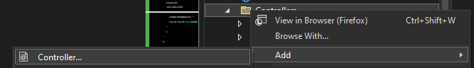
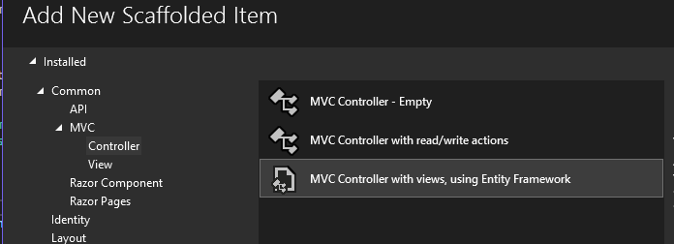
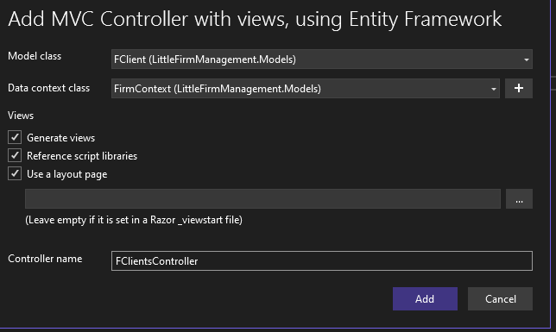

auto menu

@{
var controllers = typeof(Program).Assembly.GetExportedTypes()
.Where(x => typeof(ControllerBase).IsAssignableFrom(x) && !x.IsAbstract);

<ul class="navbar-nav mr-auto">
@foreach (var controller in controllers)
{
var controllerName = controller.Name.Replace("Controller", "");
<li class="nav-item"><a class="nav-link" asp-controller="@controllerName" asp-action="Index">@controllerName</a></li>
}
</ul>
}

Attempt 2

Base

From ps1

dotnet new mvc --name LittleFirmManagement
cd .\LittleFirmManagement\

From ps1
dotnet add package Npgsql.EntityFrameworkCore.PostgreSQL
dotnet add package Microsoft.EntityFrameworkCore.Design
dotnet add package Microsoft.EntityFrameworkCore.Tools

create appsettings
{
"ConnectionStrings": {
"DefaultConnection": "Host=localhost;Database=firm;Username=postgres;Password=admin;Port=5433"
},
"Logging": {
"LogLevel": {
"Default": "Information",
"Microsoft": "Warning",
"Microsoft.Hosting.Lifetime": "Information"
}
},
"AllowedHosts": "*"
}

From ps1
dotnet ef dbcontext scaffold name=DefaultConnection Npgsql.EntityFrameworkCore.PostgreSQL --output-dir Models --data-annotations

from PMC in VS
Scaffold-DbContext name=DefaultConnection Npgsql.EntityFrameworkCore.PostgreSQL -OutputDir Models -force

add in program.cs
using LittleFirmManagement.Models;
using Microsoft.EntityFrameworkCore;
builder.Services.AddDbContext<FirmContext>(options => options.UseNpgsql(builder.Configuration.GetConnectionString("DefaultConnection")));

create mvc crud

OU

dotnet add package Microsoft.VisualStudio.Web.CodeGeneration.Design -v 6

dotnet aspnet-codegenerator controller -dc FirmContext -name FInvoicesController -m FInvoice --relativeFolderPath Controllers --useDefaultLayout --referenceScriptLibraries
dotnet aspnet-codegenerator controller -dc FirmContext -name FCategoriesController -m FCategory --relativeFolderPath Controllers --useDefaultLayout --referenceScriptLibraries
dotnet aspnet-codegenerator controller -dc FirmContext -name FClientsController -m FClient --relativeFolderPath Controllers --useDefaultLayout --referenceScriptLibraries
dotnet aspnet-codegenerator controller -dc FirmContext -name FPurchasesController -m FPurchase --relativeFolderPath Controllers --useDefaultLayout --referenceScriptLibraries
dotnet aspnet-codegenerator controller -dc FirmContext -name FInterventionsController -m FIntervention --relativeFolderPath Controllers --useDefaultLayout --referenceScriptLibraries
dotnet aspnet-codegenerator controller -dc FirmContext -name FCitiesController -m FCity --relativeFolderPath Controllers --useDefaultLayout --referenceScriptLibraries
dotnet aspnet-codegenerator controller -dc FirmContext -name FCategoryTypesController -m FCategoryType --relativeFolderPath Controllers --useDefaultLayout --referenceScriptLibraries

copier dans Views\Shared\_Layout.cshtml

<nav class="navbar navbar-expand-sm navbar-toggleable-sm navbar-light bg-white border-bottom box-shadow mb-3">
<div class="navbar-collapse collapse d-md-inline-flex flex-md-row-reverse">
@{
var controllers = typeof(Program).Assembly.GetExportedTypes()
.Where(x => typeof(ControllerBase).IsAssignableFrom(x) && !x.IsAbstract);

<ul class="navbar-nav mr-auto">
@foreach (var controller in controllers)
{
var controllerName = controller.Name.Replace("Controller", "");
<li class="nav-item"><a class="nav-link" asp-controller="@controllerName" asp-action="Index">@controllerName</a></li>
}
</ul>
}
</div>

</nav>

Customizations

research
<form asp-controller="FClients" asp-action="Index" method="get" class="form-inline my-2 my-lg-0">
<div class="form-group">
<input type="text" name="searchString" class="form-control mr-sm-2" placeholder="Search by Name" aria-label="Search">
<button type="submit" class="btn btn-outline-success my-2 my-sm-0">Search</button>
</div>
</form>

label

ViewData["CFkMediaId"] = new SelectList(_context.FCategories.Where(c => c.CaFkCategoryType.CtId == 1), "CaId", "CaName");

clients location

<div id="mapid" style="height: 400px;"></div>

@section Scripts {
<script src="https://cdn.jsdelivr.net/npm/leaflet@1.7.1/dist/leaflet.js"></script>

<!-- Leaflet CSS -->
<link rel="stylesheet" href="https://cdnjs.cloudflare.com/ajax/libs/leaflet/1.7.1/leaflet.min.css" crossorigin="anonymous" referrerpolicy="no-referrer" />

<!-- Leaflet JavaScript -->
<script src="https://cdnjs.cloudflare.com/ajax/libs/leaflet/1.7.1/leaflet.min.js" crossorigin="anonymous" referrerpolicy="no-referrer"></script>

<script>
var mymap = L.map('mapid').setView([47.9375, -3.9585], 11);

var redIcon = L.icon({
iconUrl: 'https://cdn.rawgit.com/pointhi/leaflet-color-markers/master/img/marker-icon-red.png',
iconSize: [25, 41],
iconAnchor: [12, 41],
popupAnchor: [1, -34],
tooltipAnchor: [16, -28],
shadowSize: [41, 41]
});

L.tileLayer('https://{s}.tile.openstreetmap.org/{z}/{x}/{y}.png', {
attribution: '&copy; <a href="https://www.openstreetmap.org/">OpenStreetMap</a> contributors'
}).addTo(mymap);

// loop through each city and add a marker to the map
@foreach (var c in Model)
{
<text>var marker = L.marker([@c.CLocationLat, @c.CLocationLong], { icon: redIcon }).addTo(mymap);
marker.bindPopup("<b>@c.CName</b>"); </text>

}
</script>
}

in FCategoriesController.cs/Create
ModelState.Remove("CaFkCategoryType");

pb in FCategoriesController.cs/Create
fCategory.CaId = _context.FCategories.Select(c => c.CaId).DefaultIfEmpty().Max() + 1;

